**Diabetic Retinopathy Detection**

**Problem Statement**

In medical field, diagnosis of diseases competently carried out by using the image processing. Therefore, that to retrieve the relevant data from the amalgamation of resulting image is too difficult. Here the segmentation technique is very useful by semi-supervised learning then the result can be tuned by using Deep Learning Neural Network.

Deep neural networks have been investigated in learning latent representations of medical images, yet most of the studies limit their approach in a single supervised convolutional neural network (CNN), which usually rely heavily on a large scale annotated dataset for training. To learn image representations with less supervision involved, this problem can be solved using a deep CNN architecture that can be trained with only binary image pair information. Some researchers evaluated the learned image representations on a task of content-based medical image retrieval using a publicly available multiclass diabetic retinopathy fundus image dataset. The problem can be solved using deep CNN which requires much less supervision for training.

**Background**

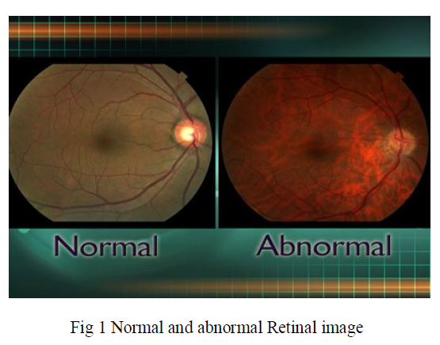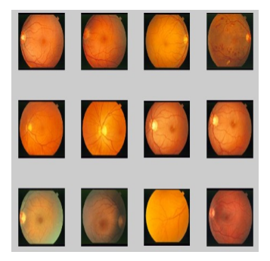

Fig2: Example of training image set

The automated extraction of blood vessels in retinal images is a major step in early diagnoses of diabetic retinopathy. Automatic segmentation of blood vessels in retinal images can be done using the Ant colony system for retinal blood vessel segmentation which is simple and fast in computation. The method multi column deep neural network(DNN) can be used for image classification of the segmented output which enhances the neural network tuning capability and resulting high performance. It is mainly used for recognizing characters, traffic signals etc. Semi supervised segmentation and DNN can be used together. To improve supervised learning for deep architectures one jointly learns an embedding task using unlabeled data. Here researchers use shallow architectures depicts embedding unlabeled data as am separate pre-processing step and using embedding as a Deep Learning Neural Network with Semi Supervised Segmentation for Predicting Retinal.

**Methodology**

The method for segmentation is shown in figure 1.

*Step 1: Data collection and dataset preparation*

This will involve collection of retinal images from various sources and pre-processing them for efficient detection of segmented regions.

*Step 2: Developing a recommender system based on predictions*

A structured DNN will be trained for detection of diabetic retinopathy.

*Step 3: Training and experimentation on datasets*

Diabetic Retinopathy detection model will be trained both on the large-scale datasets and the dataset populated based on case study.

*Step 4: Deployment and analysis on real life scenario*

The trained and tested model will be deployed in a real-life scenario for further analysis provided the data can be made available from nearby eye hospital.

|  |  |
| --- | --- |
|  |  |

Fig 3: Modules and segmentation approach

First module is optimization model from which the maxima and minima pixel values are selected and is gives to next module. Second module is similarity measures from where the pixel similarity calculated based on location or color. Third module is computational complexity from which data and time complexity measured because of entire work used in medical data set and which is large one. Fourth one is the application to collection of images in which we not only taking single image segmentation, our method implements to multiple images. Fifth module is deep learning neural network(DLNN) which provides complete tuning of image and predicting diseased image or not. Deep Learning methodology using the input image as semi supervised segmented output. In this module training the image with labeled data and un labeled data because of Deep learning could satisfies to both supervised segmentation and un-supervised segmentation. Last module is the performance evaluation from this module CPU performance time for running each image and accuracy calculated based on PSNR (Peak Signal Noise Ratio).

**Experimental Design**

*Dataset*

Diabetic Retinopathy Detection will be used for experimentation and evaluation available at: [**https://www.kaggle.com/c/diabetic-retinopathy-detection**](https://www.kaggle.com/c/diabetic-retinopathy-detection)

*Evaluation measures*

Measures such as accuracy, signal based on peak signal to noise ratio will be computed.

*Software and Hardware Requirements*

Deep learning libraries will be exploited for the development and experimentation of the project. Training will be conducted on NVIDIA GPUs for training the DNN model.